**CS 5635 Final Project:**

**Visualization of T-cell Migration within a Heterogeneous Tumor**

By Tony Zhang | u1183156.

**Overview and Goals of the Project**

Intratumoral heterogeneity (ITH) significantly impacts patient survivability by complicating effective immune responses and treatments. This project aims to develop and visualize a computational model of T-cell migration within a heterogeneous tumor environment. Specifically, T-cell movement was modeled as stochastic, influenced by local chemokine concentrations. The goal was to create detailed visualizations illustrating both the chemokine flow and concentration within the tumor and the resultant simulated T-cell migration patterns.

**Background and Related Work**

Previous mouse models failed to adequately represent tumor heterogeneity, prompting the development of an innovative mouse model by the Reeve’s lab at the Huntsman Cancer Institute, as described in their preprint (<https://pmc.ncbi.nlm.nih.gov/articles/PMC10168251/>). This model uniquely enables the study of tumors comprising both pro-inflammatory ("hot") and immunosuppressive ("cold") populations. Notably, the lab observed that CD4 helper T-cells preferentially localized in the "hot" population due to the immunosuppressive chemokine emissions of the "cold" population, which triggered macrophages to inhibit T-cell activity.

Building upon this foundation, my project focuses on scenarios involving two pro-inflammatory populations—a "hot" and a "hotter" tumor environment. Interestingly, the Reeve’s Lab found that the helper T-cells predominantly localized in the "hotter" population, challenging the immune system's effectiveness even though each tumor type individually was manageable by the mouse's immune system. This observation raised the question of whether chemokine could explain such distinct T-cell localization patterns.

**Project Description and Data Used**

The central question investigated in this project was whether T-cell attraction to chemokines could sufficiently explain their observed localization within heterogeneous “hot” and “hotter” tumors. To address this, I developed visualizations of chemokine flow and concentration within the tumor environment. Additionally, I created simulations of T-cell movement and visualized their positions and migration paths dynamically.

The data underpinning this project consisted of a 2D fluorescent microscopy image provided to me from the Reeve’s lab, containing positional data for the hotter (RFP-labeled) and hot (YFP-labeled) tumor populations, along with CD4 T-cells. This real-world data served as a spatial reference for the simulations and visualizations produced in the study.

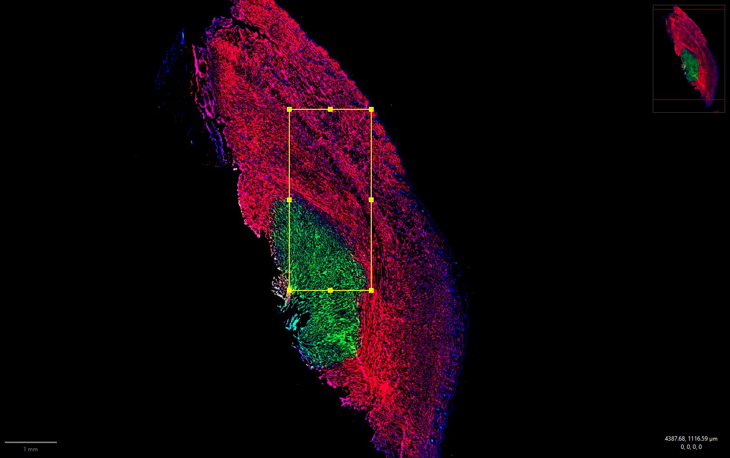

Figure : Fluorescent image of a cross section of a heterogeneous tumor. The red stains are the RFP ("hotter") cells, the green stains are the YFP ("hot") cells, and the blue stains are the CD4 helper cells. My simulation used data within the bounded box.

Throughout the project, new questions emerged, particularly regarding the suitability of chemokine gradients as the sole explanation for T-cell localization patterns, and the appropriate scaling factors necessary for accurate simulation.

**Implementation Details**

The core of the project involved solving the 2D steady-state diffusion equation, which describes chemokine distributions within the tumor. This equation was analytically solved using modified Bessel functions, as detailed in the attached solution document. Parameters for the diffusion equation were chosen based on literature describing chemokine attraction mechanisms relevant to T-cells (<https://www.frontiersin.org/journals/immunology/articles/10.3389/fimmu.2022.913366/full>).

Using this diffusion framework, I constructed a spatial grid and implemented bilinear interpolators to generate VTK files for both flow visualization (via Line Integral Convolution, LIC) and height-based chemokine concentration visualization. T-cell movement was simulated by initially placing them randomly within the spatial grid. Their subsequent stochastic movement was guided by the gradient of the chemokine concentration and modeled using a von-Mises distribution, mathematically described by:

$$f\left(x | μ,κ\right)=\frac{exp\left(κcos\left(x-μ\right)\right)}{2πI_{0}\left(κ\right)}$$

In this equation, the mean direction (μ) was aligned with the chemokine gradient, and the concentration parameter (κ) was proportional to the gradient magnitude. A scaling factor ( $c)$ further modulated T-cell sensitivity to these gradients, a larger $c$ would result in T-cells following the gradient more closely and a smaller $c$ would result in random movement. Cells moving outside defined boundaries were respawned randomly within the tumor area to maintain consistent cell counts.

The resulting VTK files, containing T-cell paths and positions, were visualized in Paraview, where LIC was applied to the vector field data. Glyphs were used to represent tumor cell and T-cell positions distinctly through color and shape, allowing for easy identification and analysis. Initial testing occurred on a smaller dataset to ensure accuracy and functionality before transitioning to the larger, full-scale dataset.

**Results:**

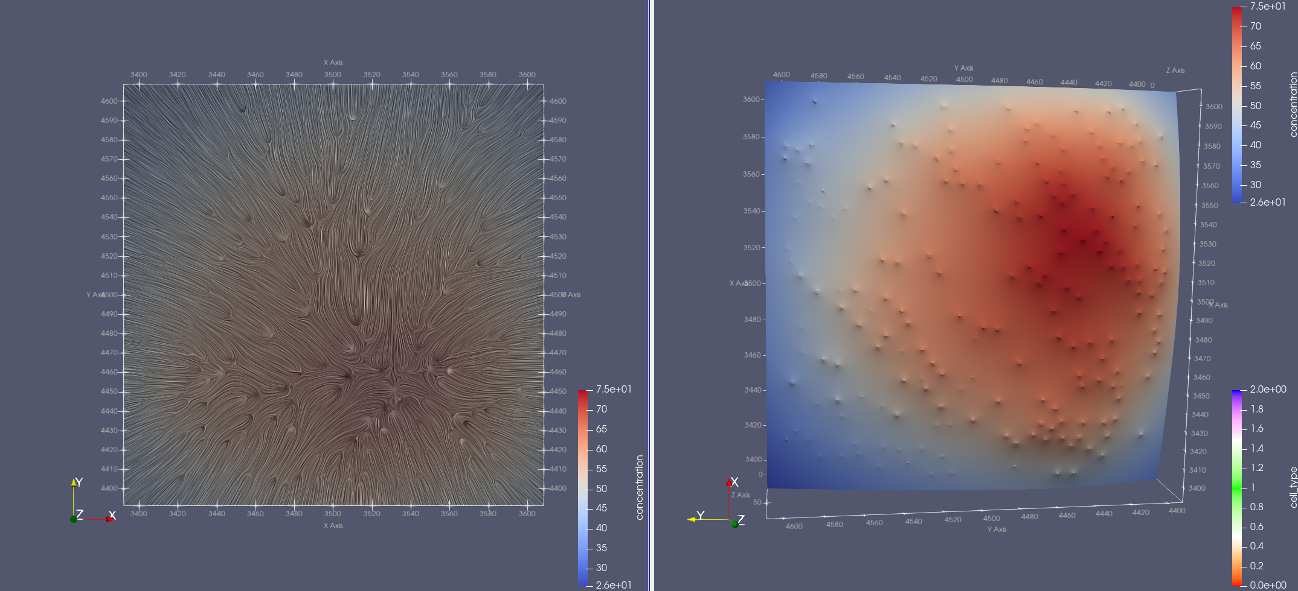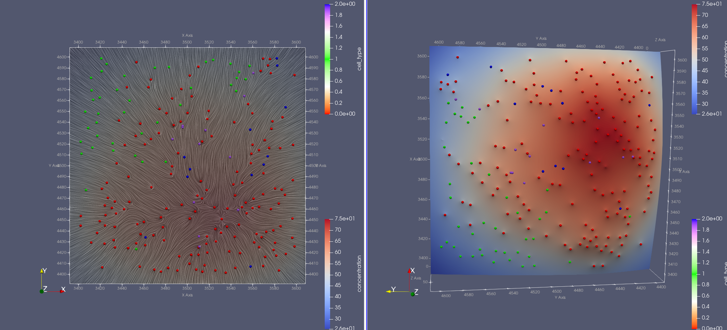

Figure : The smaller dataset which shows the flow of the chemokines via a LIC on the left side and a concentration heat map on the right. The bottom visualization shows the actual positions of the cancer cells where red are the RFP, green is the YFP and blue is the CD4 T-cell.



Figure : Animation of t-cells moving within the miniature tumor with a c of 1.

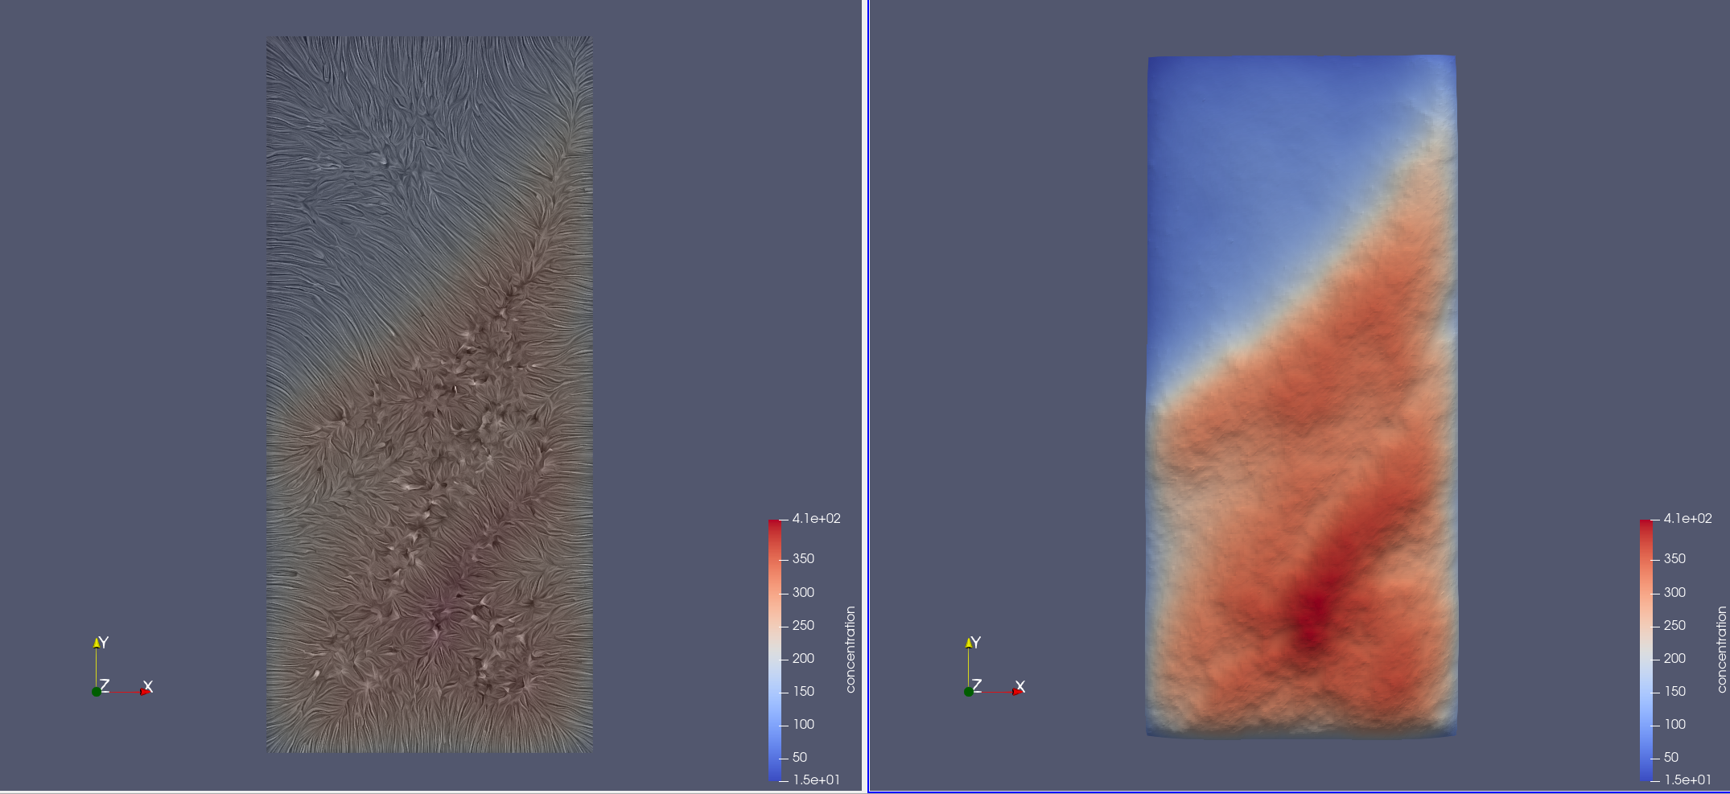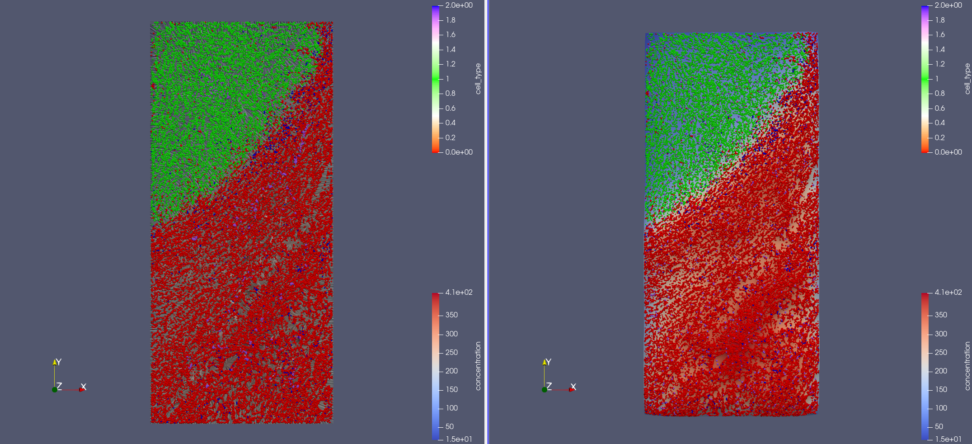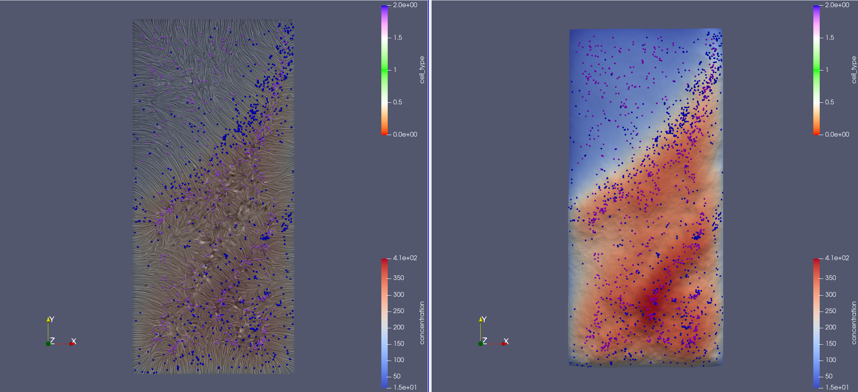

Figure : Full dataset but bottom visualization is just observed T-cells (blue) and simulated final T-cell positions (purple) with a c of 1.



Figure : Animation of T-cells moving with path lines. Left side has a c of 10 so it follows the gradient very closely. Right has a c of 0.1 so they move randomly and some leave then get new positions which can be seen with the extremely long straight pathlines.

**Lessons Learned**

One of the key lessons from this project was the considerable challenge and complexity involved in generating data rather than using pre-existing datasets. Numerous factors influenced visualization results, including path length, glyph sizing, and scaling parameters. Crucially, I found that chemokine gradients alone likely do not fully account for observed T-cell localization patterns. High scaling factors resulted in cells becoming trapped in local maxima, whereas low scaling factors failed to produce discernible localization patterns. However, the visualization method alone did not provide conclusive evidence due to the complexity and density of the cell movements.

**Project Goals Evaluation**

All intended project goals were successfully accomplished. The main deviation from the original plan involved specifying the chosen method for flow visualization (LIC), selected based on knowledge acquired during the project.

**Project Evaluation**

Overall, the project was successful in achieving its defined objectives. Nevertheless, it exhibited certain strengths and weaknesses:

**Weaknesses:**

* Visualization at larger scales was challenging due to the difficulty in distinguishing detailed positional relationships between densely packed cells. This limitation suggested that statistical methods might provide clearer insights.
* Lower scalar values caused T-cells to frequently exit the tumor boundaries, resulting in distracting visual artifacts (long streaking paths).
* The simulation, while detailed, did not fully encompass all relevant biological dynamics, such as immune cell killing mechanisms or vascular structure influences.

**Strengths:**

* The visualization effectively demonstrated how parameter adjustments influence chemokine concentration distributions within the tumor, offering a uniquely intuitive method for investigating these interactions.
* The simulation and animation provided insights into individual T-cell migration patterns and effectively highlighted the stochastic nature of their movements beyond numerical parameters alone.

**Additional Comments**

Future work could benefit from integrating statistical analyses to complement visual insights and incorporating additional biological mechanisms into the simulation to enhance biological realism.